**Station #1 Memory Game/ Card Game**

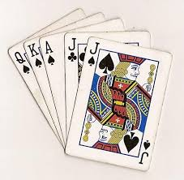 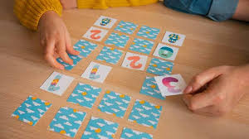

Memory Game Directions:

1. Select a memory game bag.
2. Flip over all cards and shuffle.
3. Try to make matches based off of memory. Partners take turns back and forth. Whoever gets match gets to keep the cards.
4. See who has the most at the end and be sure to congratulate each other.

Card Game Directions:

1. Select a deck of cards. One deck per partner pairing.
2. Deal them evenly between partners.
3. Both students show card at same time.
4. Highest number wins both cards.
5. Continue to play until one partner wins by having all of the cards.
6. Be a good sport to each other no matter who wins or loses.

**Station #2 Board Games and Tic Tac Toe**

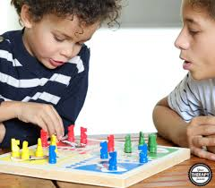 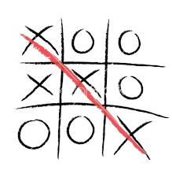

Directions:

1. Select a board game or tic tac toe game with your buddy.
2. Play the game by the rules.
3. Show humility by congratulating the winner and saying “good game”.
4. Clean up all pieces from the game when done.

**Station #3 Playdoh Pictionary and Puzzles**

 

Play-doh Pictionary Directions:

1. Select 1 playdoh color-one play-doh container per mentoring pair. DO NOT MIX COLORS!
2. Take a bag with pictures. Partner 1 selects a picture and does not show Partner 2. Then Partner 1 makes selected picture out of play-doh. Partner #2 guesses what it is.
3. Take turns and support each other even if wrong.
4. Clean up all play-doh.

Puzzle Directions:

1. Select cereal puzzle bag.
2. Complete puzzle with partner.
3. Clean up all pieces from the puzzle when done.

**Station #4 Cup Stacking and Ping pong ball with spoon**

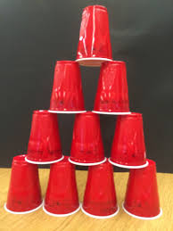 

Cup Stacking Directions:

1. The goal of the game is to take 10 cups and make them stack into a pyramid shape with four levels (four cups on the bottom, then three cups, then two cups, and one cup on top) as fast as you can. Use a stopwatch or timer to see how long it takes you to make the pyramid the first time.
2. Take turns with your partner to see who has the fastest time.
3. Congratulate the winner!

Ping pong ball with spoon directions:

1. Each partner take 1 spoon and 1 ping pong ball. Grib sppon in hand and place ping pong ball on it.
2. Walk from one side of line to the other with your partner. If one person drops the ping pong then you have to begin again.

*Challenge-Use opposite hands.